**SMALL (NO. PUMPS) PUMP SEWAGE PUMP STATION**

**OPERATION AND MAINTENANCE MANUAL**

**ASSET ID - SITE ADDRESS – PUMP OPERATION**

**THIS DOcUMENt is based on TDEMAN01 vERSION 3.0. Refer TO Appendix B for:**

* **standaRD OPTIONAL FEAtures Implemented**
* **NON-STANDARD ADDITIONS**

**THIS DOCUMENT IS TO BE READ IN CONJUNCTION with THE ELECTRICAL DRAWINGs AND FUNCTIOANL DESCRIPTION. the ELECtRICAL DRAWINGS contain details on the**

**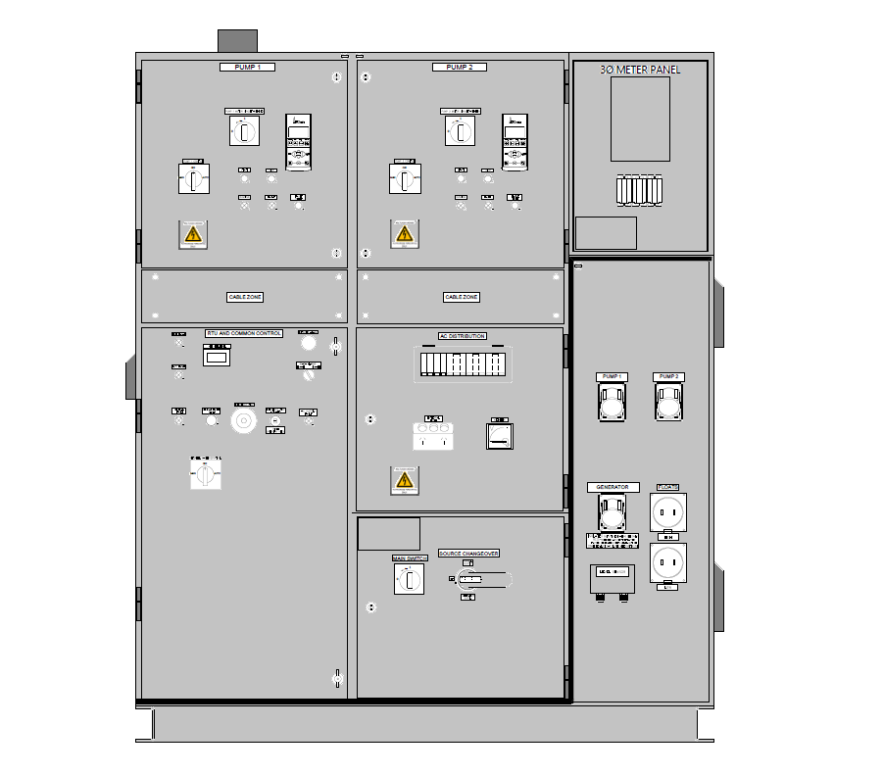SWITCHBOARD TYPE, WET WELL LEVEL SETTINGS, control mode, INSTALLED PUMPS, PUMP SIZES, RTU and COMMUNICATIONS DEVIcE TYPE.**

Instructions:

Replace the text highlighted red above as follows, once completed change the colour of the red text to match the remainder of the heading:

1. NO. PUMP: Is the number of installed pumps e.g. One or Two
2. ASSET ID: Is the ASSET ID provided by TasWater
3. SITE ADDRESS: Is the Site address provide by TasWater
4. PUMP OPERATION: Is replaced with the pump operation details. Typically, this is duty/assist, duty/standby, or duty only (for sites with one pump)

Insert the approved Alarm Review Spreadsheet (based on the TDETEM10 template) in Appendix B.

Update Appendix A as follows:

1. List any implemented standard optional features. If none are implemented the list shall say ‘none’.
2. Add approved detailed functional description for any non-standard features. This shall be based on the commissioned installation. Also add any non-typical SCADA Screenshots if necessary. If none are implanted, say ‘none’.

Note - This document is structured so Operations staff can easily identify nuances of the standard design associated with this site on the Front Page or Appendices. Minor changes within the main content of the document are easily missed.

DELETE THIS INSTRUCTION BOX PRIOR TO FINALISING THE DOCUMENT

Document Approval and Issue Notice

The Small Sewage Pump Station - O&M Manual is a controlled document. Recipients should remove superseded versions from circulation. This document is authorised for issue once it has been approved.

**PREPARED:** Sean Gardam Date: 15/03/2022

**APPROVED:** Tim Gibbs Date: 7/04/2022

Build Status:

|  |  |  |  |  |
| --- | --- | --- | --- | --- |
| **Version** | **Date** | **Author** | **Reason** | **Sections** |
| 0.1 | 18/12/2014 | Stephen Dadswell | Initial copy | All |
| 0.2 | 18/08/2015 | Nyssa Muir | SPS Design update. New TW document format. | All |
| 1.0 | 18/08/2015 | Stephen Dadswell | Approved for initial release | All |
| 1.1 | 16/07/2018 | Sean Gardam | Updates for statewide head end | All |
| 1.2 | 6/03/2020 | Tim Gibbs | Updated float indicator light colour | 3.1.2 |
| 2.0 | 15/05/2020 | Tim Gibbs | Approved | All |
| 2.1 | 15/03/2022 | Sean Gardam | Updated for new switchboard design | All |
| 3.0 | 07/04/2022 | Tim Gibbs | Approved | All |

Amendments in this release:

|  |  |  |
| --- | --- | --- |
| **Section Title** | **Section Number** | **Amendment Summary** |
|  |  |  |
|  |  |  |

Distribution:

|  |  |  |  |
| --- | --- | --- | --- |
| **Copy No** | **Version** | **Issue Date** | **Issued To** |
|  |  |  |  |
|  |  |  |  |
|  |  |  |  |

Table of Contents

[1. Safety 4](#_Toc100214042)

[1.2. How to use this manual 4](#_Toc100214043)

[1.3. Safety features of the Sewage Pump Station 4](#_Toc100214044)

[1.4. Original Equipment Manufacture’s Manuals 4](#_Toc100214045)

[1.5. Warnings 5](#_Toc100214046)

[1.6. General Safety Information 5](#_Toc100214047)

[1.7. Definitions 5](#_Toc100214048)

[2. Description of the Sewage Pump Station 6](#_Toc100214049)

[2.1. Pump Station Commissioning Date 6](#_Toc100214050)

[2.2. Key Operating Parameters 6](#_Toc100214051)

[2.3. Description of Operation 7](#_Toc100214052)

[2.4. Key Components 7](#_Toc100214053)

[3. Automatic SCADA Operation of the Pump Station 8](#_Toc100214054)

[3.1. Automatic Operation 8](#_Toc100214055)

[3.2. TYPICAL SCADA Monitoring Pages 9](#_Toc100214056)

[3.3. Trending 14](#_Toc100214057)

[3.4. Alarming 15](#_Toc100214058)

[4. Manual Local Operation 15](#_Toc100214059)

[4.1. Access & Egress 15](#_Toc100214060)

[4.2. Switchboard Designs 16](#_Toc100214061)

[4.3. Indicators & Displays 17](#_Toc100214062)

[4.4. Emergency Stop Button 18](#_Toc100214063)

[4.5. Manual Pump Operation 18](#_Toc100214064)

[4.6. Manual Wet Well Washer Operation 19](#_Toc100214065)

[4.7. Manual Odour Fan Operation 19](#_Toc100214066)

[4.8. Local Alarm/Status Handling 19](#_Toc100214067)

[4.9. Mobile Emergency Generator Connection 20](#_Toc100214068)

[5. Equipment Isolation Instructions 20](#_Toc100214069)

[6. Fault Finding – Messages & Definitions 20](#_Toc100214070)

[7. Maintenance 21](#_Toc100214071)

[7.1. Switchboard Maintenance Procedures 21](#_Toc100214072)

[7.2. Level Sensor & Float Replacement 21](#_Toc100214073)

[8. SPS Standard Design 22](#_Toc100214074)

[8.1. Appendix A: Optional Features 22](#_Toc100214075)

[8.2. Appendix B: Alarm Review Spreadsheet 23](#_Toc100214076)

# Safety

### How to use this manual

The operator must read this manual in full to understand the context for which it was written.

This manual supplements TasWater’s policies and procedures by providing adequate information to the Operator about the Sewage Pump Station (SPS). It does not contain the standard TasWater procedures that must be followed in conjunction with the instructions of this manual.

Regarding safe work practices, this manual does not provide the risk assessments, procedures and safe work method statements that are required in conjunction with the instructions found herein. To explain this, two examples are shown below:

* To isolate a pump so that it can be removed, this manual will state that the discharge valve must be closed and tagged out / locked out, but it will not state that the operator must first identify, assess and control any hazards associated with the task of closing the valve, nor does it detail how the valve must be tagged or locked out.
* To enter the Wet Well, a confined space permit is required. This manual does not specify the requirements of the confined space permit but rather notifies the operator to comply with TasWater’s requirements for confined space entry.

Regarding isolations, this manual does not provide specific instructions for locking out / tagging out equipment but rather it only states that the isolation must be carried out. It is assumed that it will be isolated as per TasWater’s standard operating procedures.

### Safety features of the Sewage Pump Station

The pump station switchboard has several safety features designed to provide a high level of operator safety:

* Emergency Stop Pushbutton to provide a fast stop of both pumps if required
* Full current pump electrical isolation switches for each pump including manual safety lock off handles
* Switchboard full current Mains Power Supply Isolation Switch including manual safety lock off handle
* Switchboard full current Generator Power Supply Isolation Switch including manual safety lock off handle
* Interlocked manual power changeover switch to select 1 only source of power for the switchboard
* Pump full load current plugs and sockets (decontactors) which are designed to safely disconnect the pump from the electrical supply even if the plug is removed when the pump is running
* Generator full load current plug and socket (decontactor) which is designed to safely disconnect the pump station from the electrical generator even if the plug is removed when the pump station is running
* Operator access only to safe sections of the switchboard by preventing access to unsafe sections.
* All new installations use extra low voltage (24V) instrumentation and control voltages

### Original Equipment Manufacture’s Manuals

The Original Equipment Manufacturers (OEM) Manual shall be referred to when performing any maintenance or setting maintenance intervals.

### Warnings

This document contains 2 types of messages to highlight certain hazards to people and machinery as follows:

|  |  |
| --- | --- |
|  | The RED “DANGER” notice always refers to hazards that will affect people’s SAFETY. It highlights that certain procedures MUST be followed to minimise the risk of injury or death to personnel. |
|  | The YELLOW “WARNING” notice always refers to hazards that may cause DAMAGE to EQUIPMENT. Damage may mean increased wear, catastrophic failure or any other adverse effect on the equipment. |

The instructions provided in the text boxes and in the section containing the text box MUST be followed.

### General Safety Information

#### Authorised and competent personnel

Only personnel authorised by TasWater are permitted to carry out any works or gain access to any of the equipment at the SPS. The instructions and information given in this manual are as explicit as is reasonably practicable. To ensure that the operation and maintenance of this plant is carried out in a safe manner and that the plant is maintained in a safe condition, these functions must only be carried out by competent personnel. Therefore, it is essential that the personnel selected for these duties have the necessary knowledge, training and experience to enable the plant to be operated and maintained in a safe manner. Only trade qualified and competent electricians shall work on any electrical equipment greater than 24 volts.

#### PPE

All personnel entering the site must adhere to TasWater policy - THSPRO05 - Personal Protective Equipment (PPE) Procedure

#### General Hazards

|  |  |
| --- | --- |
|  | Personnel are required to follow TasWater’s current procedures for managing all hazards, whether listed below or otherwise. |

* Slip and trip hazards – Uneven and/or slippery surfaces, steps, embankments etc.
* Fall hazards – Into vessels such as the Wet well, Valve Pit, Emergency storage tank, manholes etc.
* Confined spaces – Inside the Wet well, Emergency storage tank, Valve Pit, manholes etc.
* Electrocution and electrical shock – Electrical switchboard cabinets or other electrical enclosures, pump cables, lighting, solenoid valves, instruments, portable electrical equipment etc.
* Moving parts – E.g. pumps, fans, valves
* Exposure to the elements – sun, rain, wind, ice etc.
* Exposure to sewage
* Liquids (e.g. sewage, water) under pressure or gravity
* Harmful fauna - snakes, spiders etc.
* Remote location

### Definitions

|  |  |
| --- | --- |
| **Tag out / lock out** | This instruction means to isolate the equipment as per TasWater’s isolation procedures (refer TOMPRO04 - Isolation, Lockout/Tag Out Procedure). |
| **Isolate** | When referring to equipment, this means to remove the energy sources available to that equipment. The energy sources are usually either electrical energy or hydraulic energy, but other energy sources of energy may be present. |
| **SCADA** | Acronym for “Supervisory Control And Data Acquisition”. This refers to the interface system that provides remote control and monitoring of the RTU |
| **RTU** | Remote Telemetry Unit. This is the electronic control system located in the Control Building that controls the operation of the equipment at the Pump Station. |
| **Operator** | TasWater employee or contractor who is authorised, suitably trained and competent to carry out the work of operating the Pump Station. |

# Description of the Sewage Pump Station

### Pump Station Commissioning Date

Contractor/Builder to modify to suit new individual installations

### Key Operating Parameters

| **Parameter** | **Units** |  |
| --- | --- | --- |
| Maximum design flow rate into pump station from gravity sewer mains |  |  |
| Nominal flow rate into pump station from gravity sewer mains |  |  |
| Wet Well Capacity |  |  |
| Pump configuration |  |  |
| Pump 1 max flow rate |  |  |
| Pump 1 max discharge pressure |  |  |
| Pump 2 max flow rate |  |  |
| Pump 2 max discharge pressure |  |  |
| Combined pump flow rate (both pumps running at the same time) |  |  |
| Combined pump discharge pressure |  |  |
| Service Water minimum required pressure |  |  |
| Service Water maximum allowable pressure |  |  |
| Odour control system design air flow rate (if installed) |  |  |
| Odour fan power (if installed) |  |  |
| Pump weights |  |  |

### Description of Operation

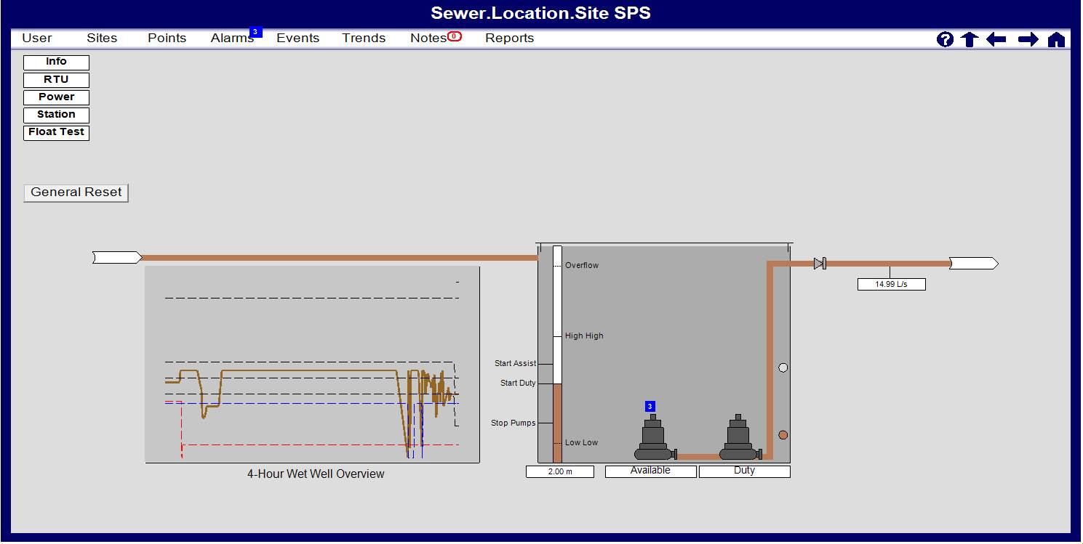

The SPS is an automatic pumping station that generally consists of a wet well, 1 or 2 pumps, an analogue level sensor and two HI & LO back up floats.

Depending on the specific site, these additional components could also be present:

* An odour fan
* Flow meter
* Wet well washer
* Emergency storage well, with or without washer
* A smoke alarm (if the switchboard is located within a building)

The station has an RTU control system that automatically controls the pumps, fans and solenoid operation with communication and alarming to TasWater via the radio (or 4G) system to TasWater’s SCADA system.

The sewage collected at the SPS comes from the surrounding catchment. Therefore, any fault / failure needs to be addressed appropriately.

### Key Components

#### Wet Well

There are one or two submersible pumps in the Wet Well that pump the sewage from the Wet Well and up to a treatment plant or another SPS.

During automatic operation at a two-pump site, the pump(s) operate in an alternating duty / standby arrangement (or duty/assist depending on SPS type). The pump(s) turn on and off according to the level of sewage in the Wet Well. The RTU monitors the wet well level and starts the duty pump when the level reaches the “START Duty pump Ctrl SP” level. If the system is duty/assist, the RTU will start the assist pump if the level reaches “START Assist pump Ctrl SP”. Once the sewage level is lowered to “STOP Pumps Ctrl SP”, the pump(s) shall turn off.

For a one-pump site, the same applies using only the “START Duty pump SP” and “STOP Pumps Ctrl SP” to control the pump. It is also possible to have both pumps arranged in series, although this is uncommon and generally limited to legacy sites – refer to the Functional Description for more details (TasWater Document TDESTD25).

All level SP’s can be viewed on SCADA, and the Duty and Assist Ctrl SP’s are operator adjustable. The next time the “START Duty pump Ctrl SP” level is reached, the duty may rotate to the other pump (refer functional description) and the cycle is repeated. For other control settings, refer to the Functional Description (TasWater Document TDESTD25).

The pumps are constant speed – the RTU commands the pumps to either be on or off. The pumps are either DOL (Direct Online) or Soft Starter (SS) controlled. The Soft Starters are on the power supply for each pump to enable a smooth ramp up to full speed and current limiting to satisfy authority requirements when the pump is turned on.

#### HI & LO Back Up Float Switches

There are also two float switches that provide back up control should the hydrostatic sensor fail.

| **Float Switch** | **Cause** | **Action** |
| --- | --- | --- |
| HI | The level in the wet well becomes too high | * If Pumps are in AUTO, Pump 1 will start. If the site is a duty/assist system, Pump 2 will also start after 5 seconds. * If in MAN, the operator will need to monitor the level to ensure overflowing does not occur. * An alarm is raised on the SCADA system (after a delay period) * The Switchboard “High Level” light shall illuminate (implies that float is tipped) |
| LO | The level in the wet well drops to a lower than normal level (below the hydrostatic sensor’s “STOP Pumps Ctrl SP” level). | * Pumps will stop when this level is reached (unless the Manual Pump mode is selected) * The Switchboard “Low Level” light shall go on (implies that float is no longer tipped) |

#### Wet Well Washer

The Wet Well has an auto washer option that activates a solenoid valve in the Water Supply Line. The washer cycle trigger and cycle running times are programmable via the SCADA.

#### Emergency Storage Well Washer

If the site has an emergency storage well, it too will generally have an auto washer option that activates a solenoid (or multiple solenoids) valve in the Water Supply Line. The washer times are set via hard wired timers in the switchboard.

#### Odour Fan

The Odour fan draws air from the Wet Well and transfers it to the Odour Control System via the vent pipe. The fan keeps the Pump Station below atmospheric pressure so that the odours cannot escape to atmosphere from any of the Pump Station tanks and manholes except through the vent pipe Odour Control System.

The fan ON/OFF times are programmable via the SCADA system.

#### Odour Control System

Description of system required is supplied with each installation as variations occur to suit each site.

# Automatic SCADA Operation of the Pump Station

### Automatic Operation

The Pump Station is designed to run automatically. When in the AUTO mode, the operation of the equipment is controlled by the Automatic RTU controller and the hardwired float switches as a backup.

|  |  |
| --- | --- |
|  | When in Automatic control the pumps, fans, solenoids etc may turn on or off at any time, without warning! |

This section details the steps required to set up each of the Pump Station components to run in automatic mode.

#### C:\Users\oudmd\Documents\TASWATER\Site Photos\IMAG1581 2.jpgPump – automatic operation

**1**

**2**

To set a pump to automatic operation, switch the mode selector for that pump to **AUTO (1).** Once in AUTO mode, the pump’s operation will be controlled by the RTU or directly via float switches and will turn on and off automatically. See the Functional Description (separate document TDESTD25) for details of how the pump operates when in AUTO mode.

To stop the pump, turn the mode selector switch to **OFF (2).**

NOTE – where a 2-pump switchboard is installed at a 1-pump site, the unused pump starter should always be placed in the ‘OFF’ position and the corresponding motor isolator switched off.

#### Wet Well auto washer – automatic operation

If installed:

To set the Wet Well auto washer to automatic operation, switch the mode selector to **AUTO (1).**

When in auto mode, the auto washer will be controlled by the RTU. The wash cycle will run based on the parameters set by the operator in the Wet Well Washer Operational Set Points in the Wet Well Popup on SCADA.

If an emergency storage is installed adjacent to the Wet Well, it too will generally have washers installed.

#### Odour Fan – Automatic Operation

|  |  |
| --- | --- |
| If installed:  To set the odour fan to automatic operation, switch the mode selector to AUTO (1).  When in AUTO mode, the odour fan is controlled by the RTU. The fan can set to run differently during 4 different periods during the day. The fan runs based on the parameters set by the operator in the Odour Fan Operational Set Points in the Station Popup on SCADA. | C:\Users\oudmd\Documents\TASWATER\Site Photos\IMAG1583 1.jpg  **1** |

### TYPICAL SCADA Monitoring Pages

Depending on the pump station area of operation, the SCADA screenshots will look similar to these following examples.

This SCADA screen is for remote users/operators and cannot be viewed onsite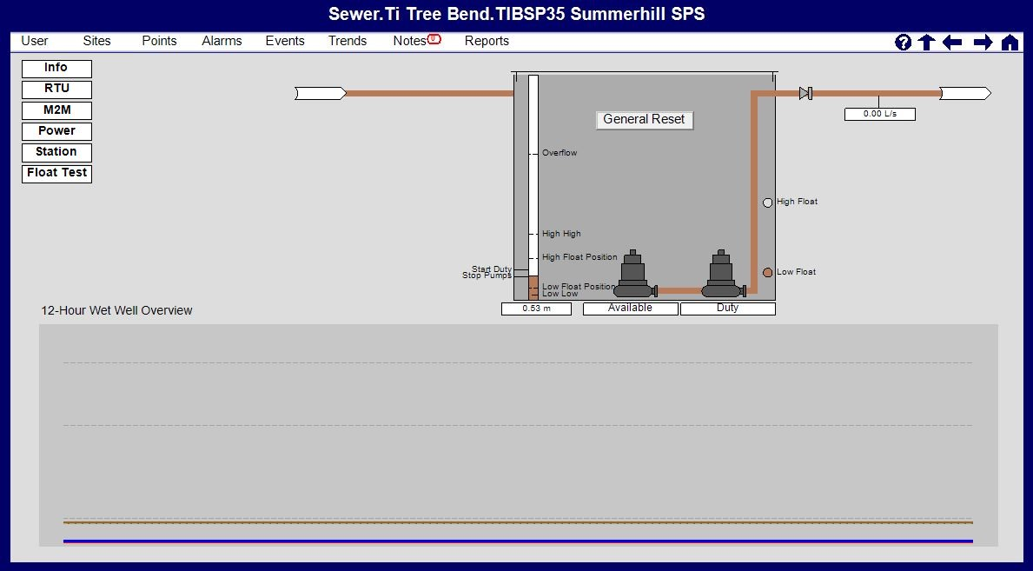

Figure 1 - Screenshot of Main Page

The Main Page contains the following real-time information:

Popup/Navigation Buttons;

* RTU: Hardware Fault and Communications Status
* Power: Mains Power Supply, Surge Diverter, and DC Power Supply/Battery Status
* Station: Design Setpoints, Switchboard Door/Intruder, Emergency Stop, Smoke Alarm (if installed) and General Site Status and Controls
* Float Test: Status and Commands associated with Float Test
* ‘Radio’ or ‘M2M’: Status and/or information regarding site communications with headend servers. Radio will display an SNMP popup for the site, M2M will link to the local telemetry overview for 3G/4G/5G connection information.
* Odour Fan: Odour Fan Controls, Alarms and Status

Devices;

* Wet well level from the level sensor (including setpoints and washdown systems)
* Outflow Sensor (If Installed)
* Pumps x1 or 2
* High and Low Float Sensors

Examples of these status pages are shown here:

|  |  |
| --- | --- |
| cid:image009.jpg@01D354B3.1EFC80A0cid:image011.jpg@01D354B3.1EFC80A0 | cid:image010.jpg@01D354B3.1EFC80A0  Figure 2 – Wet Well Status, Alarms and Controls |

|  |  |
| --- | --- |
| cid:image029.png@01D354B3.1EFC80A0cid:image027.png@01D354B3.1EFC80A0 | cid:image028.png@01D354B3.1EFC80A0  Figure 3 – Pump Status, Alarms and Controls |

|  |  |
| --- | --- |
| cid:image015.png@01D354B3.1EFC80A0 | cid:image016.png@01D354B3.1EFC80A0 |
| Figure 3 - RTU Status and Alarms  cid:image018.png@01D354B3.1EFC80A0 | cid:image019.png@01D354B3.1EFC80A0 |

Figure 5 - Power Status and Alarms

|  |  |
| --- | --- |
| cid:image021.png@01D354B3.1EFC80A0 | cid:image022.png@01D354B3.1EFC80A0 |
|  |  |

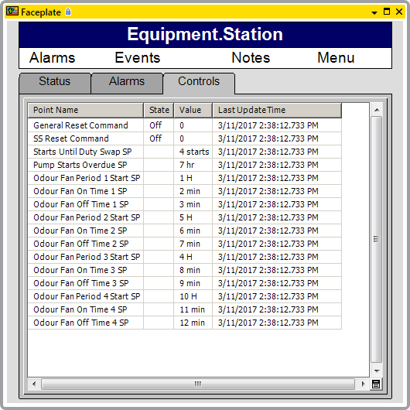

Figure 4 – Station Status, Alarms and Controls

### Trending

The standard that is included with the standard SSPS SCADA mimic includes:

* Wet Well Level
* Wet Well Setpoints (Top of Well, Overflow, Pump Start and Stop SP’s)
* Pump Currents

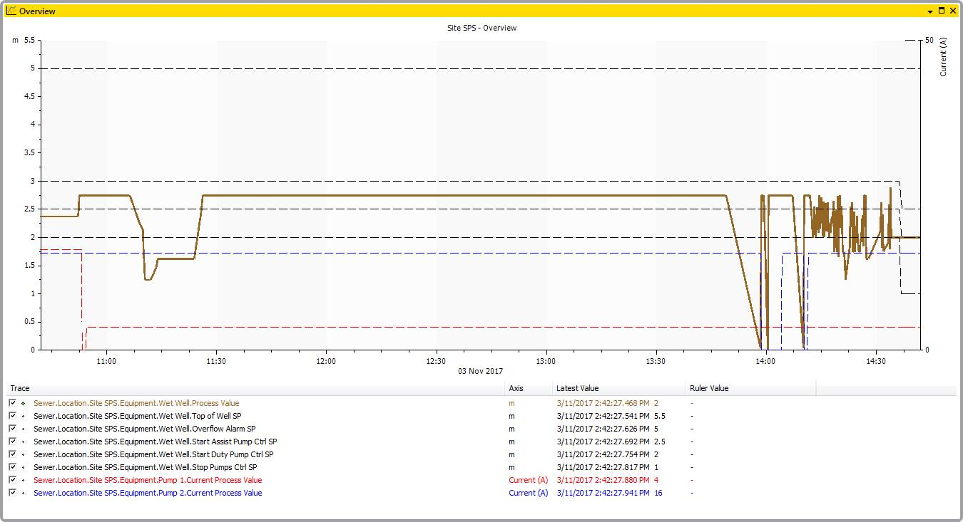

Figure 5 - SCADA Trend Page

### Alarming

Alarms are generated in the RTU and enunciated on SCADA in accordance with TDESTD15 SCADA Technical Standards and TOMSTD02 SCADA Alarm Philosophy. The RTU manages alarm suppressions and delays, while Alarm severities are defined in SCADA. Acknowledged alarms remain visible on SCADA until the fault condition has cleared.

Typical alarm severities, latching modes and resetting conditions, response times and corrective actions required for each fault condition are specified in TDETEM10 - TDESTD25 - Small (Two Pump) Sewage Pump Station - Functional Description - Appendix A Template. Prior to deployment of each station, the alarm severities are to be revised in accordance with the risk matrix defined in TOMSTD02 SCADA Alarm Philosophy.

# Manual Local Operation

### Access & Egress

There are two TasWater entry points - one through the two larger main doors at the front of the switchboard and one via the smaller lower door on the front of the cabinet.

| **Door** | **Access to:** |
| --- | --- |
| Main door at the front of the cabinet would be the initial method of entry as this provides entry to all the pump station controls | Pump Station controls  Pump main isolators  Indicators and displays  Power Distribution section |
| Smaller lower door on the cabinet provides access to the cabling zone | Pump power cable plugs and sockets for easy Disconnection of the pumps  Emergency generator connection socket  Flow meter and level sensor  Float switch connectors  Underground cable conduits to wet well & other devices |
| Third smaller door (above the cabling zone) | Access to Energy Retailer metering panel |

#### Entering

1. Unlock & Open main switchboard door.

NOTE: Once a door has been opened, closing the door does not stop the intruder alarm from activating – the disable switch must be used via the procedure below.

1. Turn the SCADA alarms switch to the ‘DISABLE’ position (within 30 sec of opening door).

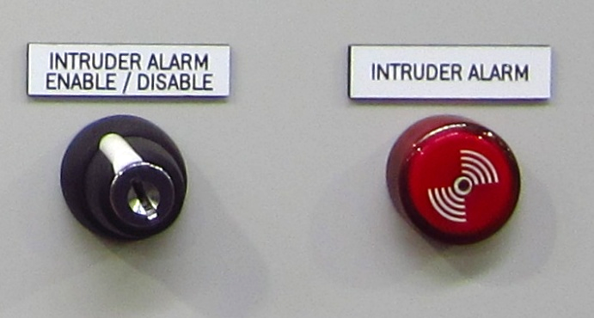

NOTE: If the key switch is not set to ‘DISABLE’ within 30 seconds, and ‘Intruder Alarm’ is generated

1. All Doors are now able to be opened, and all alarms (except for Emergency Stop, Smoke Alarm, High Float Sustained and RTU internal alarms) are suppressed while the SCADA alarms switch is set to ‘DISABLE’ and the doors are open.

#### Exiting

1. Close and lock all switchboard doors apart from the main switchboard door.
2. Turn the SCADA Alarm switch to ‘ENABLE’ position. The operator now has 30 seconds to close the main switchboard door.
3. Close main switchboard door and lock.

NOTE: If after 30 seconds the door(s) switches are not closed, an ‘Intruder Alarm’ is created and the buzzer will activate.

NOTE: If the key switch is left in ‘Disable’ and all doors are closed, then the buzzer will activate immediately and an ‘Intruder Alarm’ is generated.

### Switchboard Designs

The sewage pump station is designed to be completely contained within the cabinet. To operate the pump station the operator will first need to enter the cabinet using a standard TasWater key.

The main door at the front of the cabinet would be the initial method of entry as this provides entry to all the pump station controls including:

* Pump Station controls
* Pump main isolators
* Indicators and displays
* Power Distribution section

The lower side section has been reserved for the cableway, the metering panel, pump power cable plugs and sockets for easy disconnection of the pumps.

* Emergency generator connection socket
* Flow meter (if installed) and level sensor
* Float switch connectors
* Underground cable conduits to wet well and other services

A third smaller door is also positioned above the cable section and this is for Electricity Supply Authority access to their metering panel.

### Indicators & Displays

The pump station switchboard is provided with multiple indicators and displays.

| **Equipment** | **Information Available** |
| --- | --- |
| Wet Well Level Sensor (0 to 10m) | Wet well depth in meters  (bottom of level sensor, not bottom of wet well) |
| Outflow Flow Sensor (0 to 100 l/s) (if installed) | Pump flow in litres / second. Shown on the switchboard display and on the flow meter transmitter. *If installed.* |
| **Orange** High Level Float Indicator lamps | ‘ON’ - float switch is submerged (abnormal operation)  ‘OFF’ - float is hanging in air (normal operation |
| **Orange** Low Level Float Indicator lamps | ‘OFF’ - float switch is submerged (normal operation)  ‘ON’ - float is hanging in air (abnormal operation) |
| Pump electrical current in Amps (DOL switchboard only) | DOL starter current shown on Ammeter *If installed*, Soft Starer current shown on soft starter display |
| **Green** Pump Running Indicator Lamp | The pump manual start push button illuminates when the pump is running |
| Electricity Authority Mains Supply Fault Lamp | Loss of mains power has occurred when illuminated. |
| Switchboard Supply Voltmeter | Displays the 3-phase voltage of either Electricity Supply Authority supply or generator supply. |
| **Amber** General Fault Indicator Lamp | The General Fault Reset pushbutton will illuminate when the switchboard has a general fault |
| **Amber** Pump Fault Indicator Lamp | The Pump Fault lamp will illuminate when the specific pump has a fault |
| Pump Soft Starter (SS switchboard only) | Pump current and starting information |
| **Red** Intruder Alarm Buzzer & Lamp | Illuminates when Switchboard Door is opened. |

### S:\Jobs\3337.000 Tas Water General\3337.085 Sewage PS Generic Manual\2100 Photos\20141216 - SPS_Switchboards (1).JPGEmergency Stop Button

#### Emergency Stopping of Pumps

If there is an emergency that requires the pumps to be stopped, hit the EMERGENCY STOP button and both Pumps will stop and both pump fault lamps will illuminate.

#### Resetting after emergency stop

To reset the equipment after hitting the emergency stop button:

1. Reset the EMERGENCY STOP button by turning it clockwise and then releasing. The button should pop out to its original position.
2. The Emergency Stop Activated / reset button should be illuminated after the EMERGENCY STOP button has been activated. Press the EMERGNECY STOP RESET button to reset the emergency stop alarm.

### Manual Pump Operation

|  |  |
| --- | --- |
|  | After stopping in manual mode, the pumps will not automatically re-start and there is the risk of overflowing the Pump Station. The Wet Well level must always be monitored when in manual mode. If the site is a soft starter switchboard, each pump has a soft starter to reduce the current on start-up. The soft starter display panel have been set up to suit the requirements of the pumps they control. These settings should not be altered unless authorised by a TasWater electrical engineer. |

#### Manual Operation

|  |  |
| --- | --- |
|  | POTENTIAL TO DAMAGE EQUIPMENT – THE PUMPS WILL BE DAMAGED IF RUN DRY (“DRY” MEANING THAT THE IMPELLOR IS NOT SUBMERGED IN A LIQUID). The operator must always monitor the wet well level and must stop the pump as soon as the sewage level reaches the top of the pump inlet. |

1. To set a pump to manual operation, switch the mode selector for that pump to MAN
2. Confirm the fault lamp for the pump is not illuminated (if it is, rectify the fault)
3. Press the green START / RUN button.
4. Press the STOP button to stop the pump

Press the EMERGENCY button to stop the pump in an emergency

1. MAN mode will override the low-level switch and the pump will run continuously until the stop button is pressed**.** Continue to monitor pump operation at all times when in manual mode.

#### Turning the Pumps OFF

|  |  |
| --- | --- |
|  | PUMPS WILL NOT START IN AUTOMATIC MODE IF REQUIRED – IF LEFT IN ‘OFF’ PUMPS WILL NOT START WHEN REQUIRED AND OVERFLOWING COULD OCCUR. |

1. Select ‘OFF’ on the pump specific Auto-Off-Manual selector switch.

### Manual Wet Well Washer Operation

|  |  |
| --- | --- |
|  | WASHER WILL NOT START IN AUTOMATIC MODE IF REQUIRED |

The Wet Well washer selector switch has three options; Manual – Off – Auto.

**1.** To set the Wet Well auto washer to manual operation, switch the mode selector to MAN.

Wet well washer will run continually.

**2.** To turn off the well washer, set the selector switch to OFF.

Wet well washer will not operate. Washer will not run even if commanded to by the RTU Program.

### Manual Odour Fan Operation

|  |  |
| --- | --- |
|  | FAN WILL NOT START IN AUTOMATIC MODE IF REQUIRED |

The Odour Fan selector switch has three options; Manual – Off – Auto.

**1.** To set the Odour Fan auto washer to manual operation, switch the mode selector to MAN.

The Odour Fan will run continually.

**2.** To turn off the Odour Fan, set the selector switch to OFF.

The Odour Fan will not operate. The Fan will not run even if commanded to by the RTU Program.

### Local Alarm/Status Handling

The following alarms or equipment status are observable on SCADA by the operator. These will appear regardless of operational mode (Manual/Off/Automatic) provided nobody is at site with the alarm switch in the ‘disable’ position

| **Alarm** | **Cause** | **Action** |
| --- | --- | --- |
| Low Float Level | Wet well level is low | If pumps are in MAN mode, ensure that there is no risk of pumps dry running. |
| High Float Level | Wet well level is too high | If pumps are in MAN mode, ensure that wet well level does not overflow.  If the pump mode is in Auto, both pumps will start running if there are no faults. |
| Pump 1 FAULT | Fault with Pump 1 | 1. Ensure the pump CB is closed, overload or soft starter is healthy and E-stop is not active. 2. Press RESET button. 3. If no other faults active, call SCADA operator or OCC to interrogate the RTU and SCADA alarms. |
| Pump 2 FAULT | Fault with Pump 2 | As above |
| General Fault | Any fault has occurred – refer to TDESTD25 for full explanation of general fault lamp triggers | * + - 1. Press “GENERAL FAULT” push button to clear.       2. If fault persists, analyse the board to set what other faults are active.       3. If no other faults active, call SCADA operator or OCC to interrogate the RTU and SCADA alarms. |
| Intruder Alarm | Door has been opened without operating the SCADA alarm disable switch, or the door has been closed without re-enabling the switch | Disable with keyed switch. See section 4.1 on accessing the switchboard. |
| Electricity Supplier Fault | Power supply has failed. | If pump station is urgently required, connect emergency mobile generator. See section 4.8. |

### Mobile Emergency Generator Connection

The following minimum sized generators are required for following sized 2 pump, pump stations:

2 pumps 0 to 11 kW 44kVA Generator set (3 phase, neutral & earth)

2 pumps > 11 to 22 kW 110kVA Generator set (3 phase, neutral and earth)

To connect the emergency generator to the Pumping Station, follow these TasWater standard procedures:

- TOMWIS37 - Safe Connection of Portable/Trailered LV Generators

- TOMWIS38 - SOP Safe Connection of Portable Trailered LV Generators to Small Sewage Pump Station – Operators.

# Equipment Isolation Instructions

To carry out isolation of switchboard, pumps or other equipment please follow procedures and policies as outlined in TOMPRO04 - Isolation, Lockout/Tag Out Procedure.

# Fault Finding – Messages & Definitions

Individual messages will appear on the SCADA as Alarms and are not apparent to the operator onsite. If the general fault lamp at site is ON, the operator can call the OCC to obtain a description of the current alarms present for the site (provided the SCADA alarm switch is set to ‘ENABLE’). For further information on the alarms, the automatic responses and the reset procedures, refer to Appendix A of the Functional Description (document TDESTD25/TDETEM10).

# Maintenance

|  |  |
| --- | --- |
|  | Consult the Data Manual and manufacturer’s instructions and recommendations |

Maintenance operations and servicing must be carried out in accordance with the manufacturer’s instructions and recommendations.

Persons operating and maintaining the equipment are advised to familiarise themselves with the Data Manual.

### Switchboard Maintenance Procedures

The following table details the recommended Switchboard maintenance tasks.

| **Task** | **Interval** |
| --- | --- |
| **Thermal imaging**  Ideally to be done in-service (or immediately after isolation). The objective is to locate ‘hot spots’ in the electrical and mechanical equipment. | Every 2 years |
| **Instrumentation check**  Check each parameter indication device (wet well level, voltmeter, pump current ammeter, pump start counter) for correctness. | Annually |
| **Soft Starter check**  If installed, check the Soft Starter interface for any fault codes. | Annually |
| **Battery Check**  Perform a visual check of the VRLA batteries for any leaks, cracking or bulging in the outer case.  Check Battery charger for any faults. | Annually |
| **Battery Replacement**  Replace VRLA battery with new. Test to ensure proper operation. | Every 10 years. |
| **Instrumentation Calibration**  Calibration of analogue instrumentation (flow meter, level sensor etc.). Follow manufacturer’s instructions. | Following replacement or servicing of devices |
| **General Cleanliness Check**  Ensure no accumulation of dust or other contaminates on electrical equipment. | Annually |

### Level Sensor & Float Replacement

The level sensor and floats can be replaced without the need to enter the Wet Well which is a Confined Space.  The following risk have been identified and shall be addressed through TasWater HSE procedures:

1. Sewer gases / Airborne Contaminants.
2. Live edge, working at heights, when the wet well lid is opened.
3. Manual handling.

Care should be taken to unsure the replacement level sensor or float(s) are placed at the same depth inside the wet well as the instrument that was removed.

# SPS Standard Design

The standardised SPS design is based on the following:

1. TDESTD101 - TasWater Electrical & SCADA Technical Standard – Design – Section 6.
2. TDESTD102 - TasWater Electrical & SCADA Technical Standard - Construction & Application – Section 24.

Individual pump stations are based on these designs and tailored to suit each individual installation as required.

The [TW00-160743968-122 - Pitt & Sherry Standard SPS Switchboard Safety in Design Report](https://taswater.sharepoint.com/sites/KMHub/_layouts/15/DocIdRedir.aspx?ID=TW00-160743968-122) includes a SiD Hazard Register in Appendix B that contains identified hazards associated with the Standard SPS Switchboard Design.

### Appendix A: Optional Features

Standard Optional Features:

* None

Instructions:

1. Delete any dot points on this page that are not relevant to the specific site (if none are installed, delete all points except ‘None’).
2. Add approved detailed functional description for any non-standard features. This shall be based on the commissioned installation. Also add any non-typical SCADA Screenshots if necessary.

Note - This document is structured so Operations staff can easily identify nuances of the standard design associated with this site on the Front Page or Appendices. Minor changes within the main content of the document are easily missed.

DELETE THIS INSTRUCTION BOX PRIOR TO FINALISING THE DOCUMENT

* Flow Meter
* Odour Fan
* Well Washer
* Smoke Alarm
* Emergency Storage

Non-Standard Optional Features:

* None

### Appendix B: Alarm Review Spreadsheet

Refer to XXXX.

### Appendix C: SiD Report for the Site Design

Refer to XXXX.

In addition to the SiD report for the site design refer to [TW00-160743968-122 - Pitt & Sherry Standard SPS Switchboard Safety in Design Report](https://taswater.sharepoint.com/sites/KMHub/_layouts/15/DocIdRedir.aspx?ID=TW00-160743968-122) which includes a SiD Hazard Register in Appendix B which identifies hazards associated with the Standard SPS Switchboard Design.